PHISHING EMAIL DETECTION MODEL USING MACHINE LEARNING

Intern Details
Intern ID: 25it047-svg
Full Name: KANIYAMUTHU B
No. of Weeks: 4 Weeks
Project Name: Phishing Email Detection Model

1. Abstract
The Phishing Email Detection Model is a Machine Learning application developed using Python and Scikit-Learn. The system analyzes email text and classifies emails as either phishing or safe. This project demonstrates the use of Natural Language Processing and Machine Learning techniques for cybersecurity applications.

2. Introduction
Phishing attacks are one of the most common cybersecurity threats. Attackers send fraudulent emails to steal sensitive information such as passwords, banking details, and personal data. This project develops a Machine Learning model capable of detecting phishing emails using textual analysis.

3. Objectives
- Detect phishing emails.
- Classify emails as Safe or Phishing.
- Extract text features from emails.
- Display accuracy and confusion matrix.
- Improve cybersecurity awareness.

4. Software Requirements
- Python 3.x
- Pandas
- Scikit-Learn
- Google Colab

5. Methodology

Step 1: Dataset Creation
A dataset containing phishing and safe emails is created.

Step 2: Text Processing
TF-IDF Vectorizer converts email text into numerical features.

Step 3: Model Training
A Logistic Regression model is trained using the dataset.

Step 4: Evaluation
Model accuracy and confusion matrix are calculated.

Step 5: Prediction
The model predicts whether a user-entered email is phishing or safe.

7.Screenshots

1.Code in google colab:

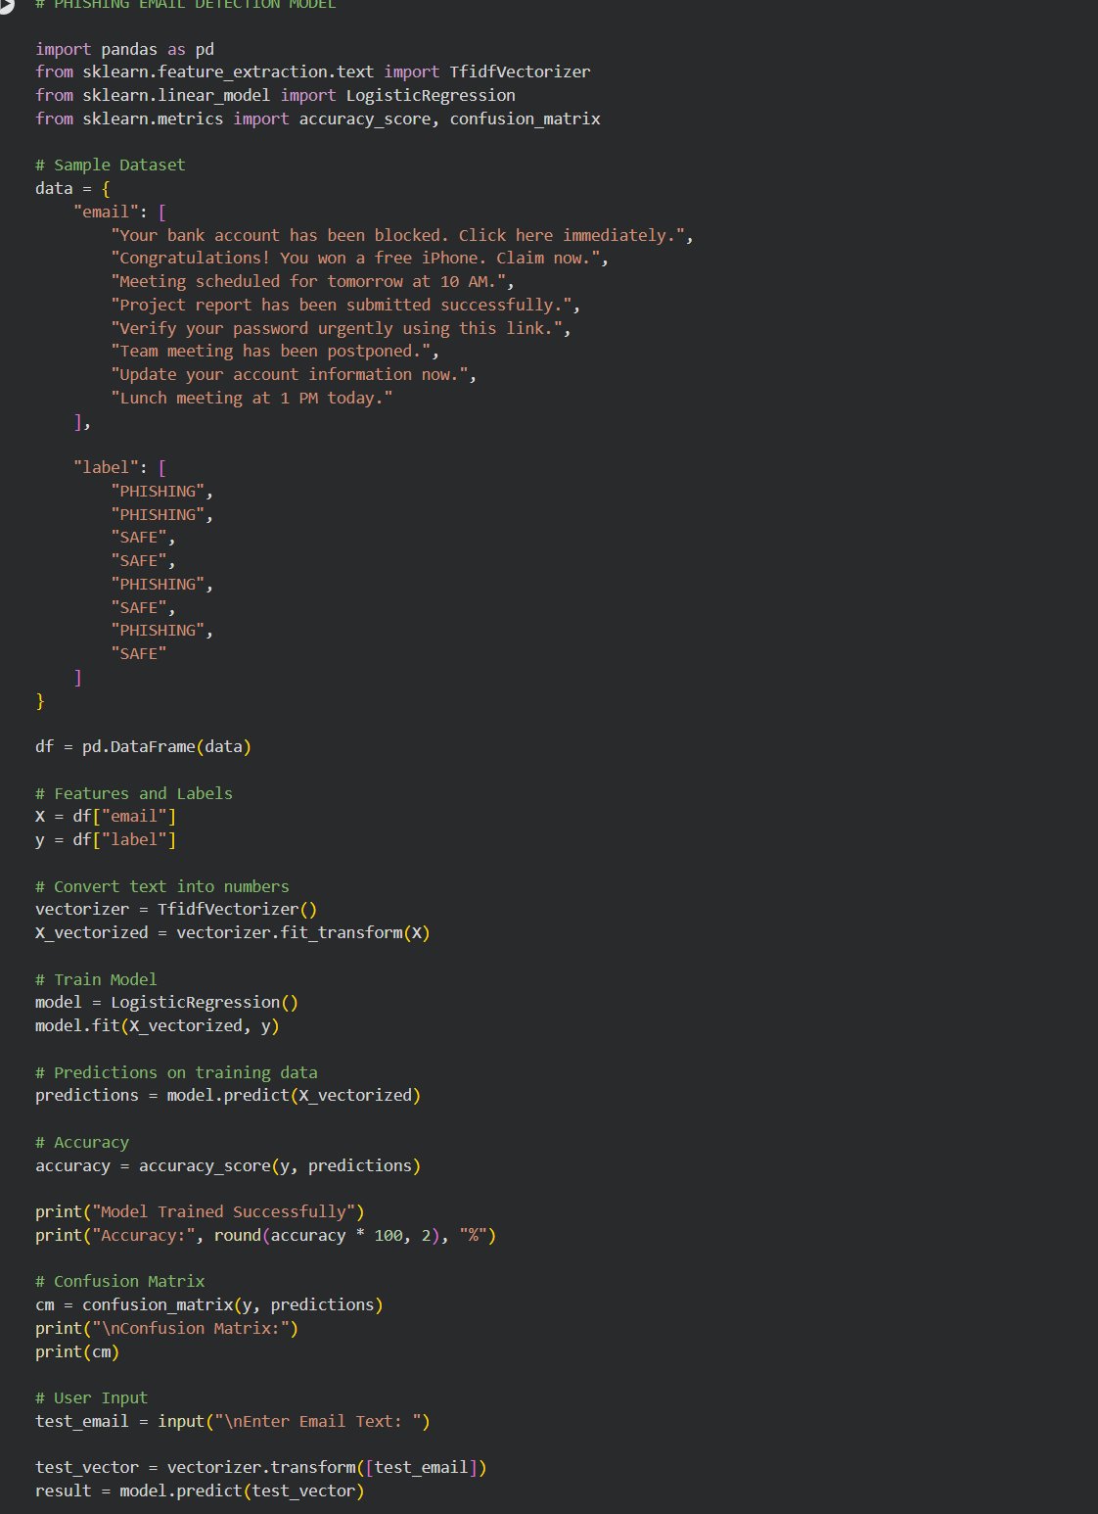

2.Output of the code:

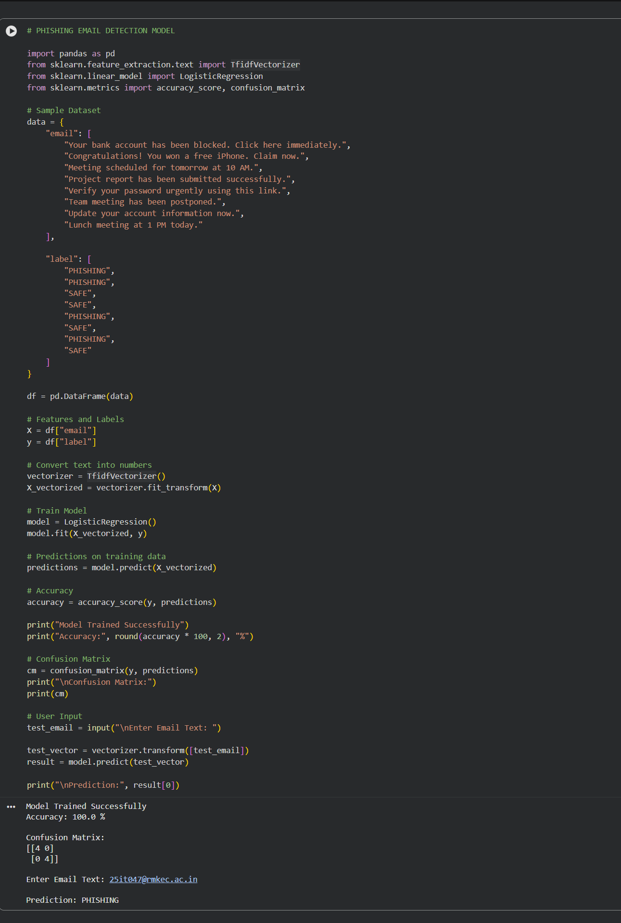

8. Output
The system displays:
- Model Accuracy
- Confusion Matrix
- Email Classification Result

Sample Output
Model Trained Successfully
Accuracy: 100.0%
Prediction: PHISHING

9. Future Enhancements
- URL Feature Analysis
- Email Header Analysis
- Deep Learning Models
- Real-Time Email Scanning
- Browser Extensions

10. Conclusion
The Phishing Email Detection Model successfully demonstrates the use of Machine Learning and Natural Language Processing techniques to identify phishing emails. The project highlights the importance of cybersecurity and intelligent email filtering systems.

References
- Python Documentation
- Pandas Documentation
- Scikit-Learn Documentation
- Google Colab Documentation
- Machine Learning Fundamentals

